1. В подключенном MySQL репозитории создать базу данных “Друзья человека”;
2. Создать таблицы с иерархией из диаграммы в БД;
3. Заполнить низкоуровневые таблицы именами(животных), командами которые они выполняют и датами рождения;

﻿ **kirk@ubuntu:~$** sudo mysql -p

mysql> create database ManFriends;

mysql> use ManFriends;

mysql> CREATE TABLE Cat (

-> id INT AUTO_INCREMENT,

-> Nick VARCHAR(20),

-> BirthDay DATE,

-> Commands SET('Sit','Stay','Fetch','Pounce','Roll','Hide',

-> 'Paw','Bark','Scratch','Spin','Meow','Jump','Trot',

-> 'Canter','Gallop','Walk','Carry Load','Bray','Kick','Run'),

-> PRIMARY KEY(id));

mysql> CREATE TABLE Dog (

-> id INT AUTO_INCREMENT,

-> Nick VARCHAR(20),

-> BirthDay DATE,

-> Commands SET('Sit','Stay','Fetch','Pounce','Roll','Hide',

-> 'Paw','Bark','Scratch','Spin','Meow','Jump','Trot',

-> 'Canter','Gallop','Walk','Carry Load','Bray','Kick','Run'),

-> PRIMARY KEY(id));

mysql> CREATE TABLE Hamster (

-> id INT AUTO_INCREMENT,

-> Nick VARCHAR(20),

-> BirthDay DATE,

-> Commands SET('Sit','Stay','Fetch','Pounce','Roll','Hide',

-> 'Paw','Bark','Scratch','Spin','Meow','Jump','Trot',

-> 'Canter','Gallop','Walk','Carry Load','Bray','Kick','Run'),

-> PRIMARY KEY(id));

mysql> CREATE TABLE Horse (

-> id INT AUTO_INCREMENT,

-> Nick VARCHAR(20),

-> BirthDay DATE,

-> Commands SET('Sit','Stay','Fetch','Pounce','Roll','Hide',

-> 'Paw','Bark','Scratch','Spin','Meow','Jump','Trot',

-> 'Canter','Gallop','Walk','Carry Load','Bray','Kick','Run'),

-> PRIMARY KEY(id));

mysql> CREATE TABLE Camel (

-> id INT AUTO_INCREMENT,

-> Nick VARCHAR(20),

-> BirthDay DATE,

-> Commands SET('Sit','Stay','Fetch','Pounce','Roll','Hide',

-> 'Paw','Bark','Scratch','Spin','Meow','Jump','Trot',

-> 'Canter','Gallop','Walk','Carry Load','Bray','Kick','Run'),

-> PRIMARY KEY(id));

mysql> CREATE TABLE Donkey (

-> id INT AUTO_INCREMENT,

-> Nick VARCHAR(20),

-> BirthDay DATE,

-> Commands SET('Sit','Stay','Fetch','Pounce','Roll','Hide',

-> 'Paw','Bark','Scratch','Spin','Meow','Jump','Trot',

-> 'Canter','Gallop','Walk','Carry Load','Bray','Kick','Run'),

-> PRIMARY KEY(id));

mysql> show tables;

+------------------------+

| Tables_in_ManFriends |

+------------------------+

| Camel |

| Cat |

| Dog |

| Donkey |

| Hamster |

| Horse |

+------------------------+

mysql> INSERT INTO Cat (Nick, BirthDay, Commands) VALUES

-> (‘Twix’, '2023-05-15', ('Sit,Pounce')),

-> (' Vasya', '2020-02-20', ('Sit,Pounce,Scratch')),

-> (' Dymok', '2020-06-30', ('Meow,Scratch,Jump'));

mysql> INSERT INTO Dog (Nick, BirthDay, Commands) VALUES

-> ('Rex', '2022-01-01', ('Sit,Stay')),

-> ('Richy', '2020-12-10', ('Sit,Paw,Bark')),

-> ('Roza', '2021-11-11', ('Sit,Stay'));

mysql> INSERT INTO Hamster (Nick, BirthDay, Commands) VALUES

-> ('Pinky', '2021-03-10', ('Roll,Hide')),

-> ('Brain', '2021-08-01', ('Roll,Spin'));

mysql> INSERT INTO Horse (Nick, BirthDay, Commands) VALUES

-> ('Monster', '2015-07-21', ('Trot,Canter,Gallop')),

-> ('Storm', '2014-05-05', ('Trot,Canter')),

-> ('Ivan', '2016-02-28', ('Trot,Jump,Gallop'));

mysql> INSERT INTO Camel (Nick, BirthDay, Commands) VALUES

-> ('Sandy', '2016-11-03', ('Walk,Carry Load')),

-> ('Klaus', '2018-12-12', ('Walk,Sit')),

-> ('Sonya', '2015-08-14', ('Walk,Run'));

mysql> INSERT INTO Donkey (Nick, BirthDay, Commands) VALUES

-> ('Evgen', '2017-09-18', ('Walk,Carry Load,Bray')),

-> ('Sandra', '2019-01-23', ('Walk,Bray,Kick'));

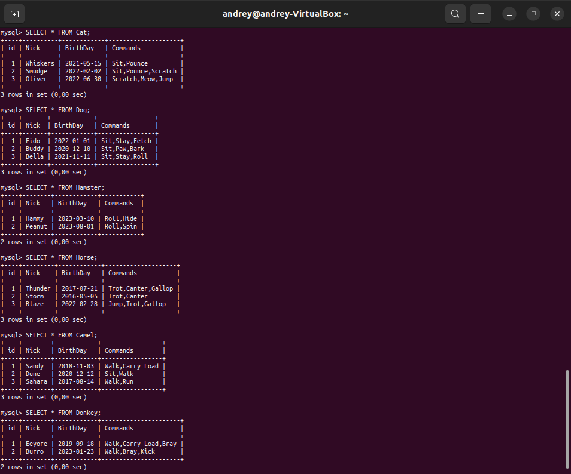

1. Удалить таблицу верблюдов, т.к. верблюдов решили перевезти в другой питомник на зимовку. Объединить таблицы лошади, и ослы в одну таблицу.

mysql> DELETE FROM Camel;

mysql> CREATE TABLE Packs (

-> id INT AUTO_INCREMENT,

-> Typee VARCHAR(12),

-> Nick VARCHAR(20),

-> BirthDay DATE,

-> Commands SET('Sit','Stay','Fetch','Pounce','Roll','Hide'

-> 'Paw','Bark','Scratch','Spin','Meow','Jump','Trot',

-> 'Canter','Gallop','Walk','Carry Load','Bray','Kick','Run'),

-> PRIMARY KEY(id));

mysql> INSERT INTO Packs (Typee, Nick, BirthDay, Commands)

-> SELECT 'Horse', Nick, BirthDay, Commands FROM Horse

-> UNION ALL SELECT 'Camel', Nick, BirthDay, Commands FROM Camel

-> UNION ALL SELECT 'Donkey', Nick, BirthDay, Commands FROM Donkey;

1. Создать новую таблицу “молодые животные” в которую попадут все животные старше 1 года, но младше 3 лет и в отдельном столбце с точностью до месяца подсчитать возраст животных в новой таблице

mysql> CREATE TABLE YoungAnimals (

-> id INT AUTO_INCREMENT,

-> Typee VARCHAR(12),

-> Nick VARCHAR(20),

-> BirthDay DATE,

-> Commands SET('Sit','Stay','Fetch','Pounce','Roll','Hide',

-> 'Paw','Bark','Scratch','Spin','Meow','Jump','Trot',

-> 'Canter','Gallop','Walk','Carry Load','Bray','Kick','Run'),

-> Age TEXT,

-> PRIMARY KEY(id));

mysql> INSERT INTO YoungAnimals (Typee, Nick, BirthDay, Commands, Age)

-> SELECT Typee, Nick, BirthDay, Commands,

-> CONCAT(TIMESTAMPDIFF(MONTH, BirthDay, CURDATE()) div 12, ' year, ',

-> TIMESTAMPDIFF(MONTH, BirthDay, CURDATE()) % 12, ' month')

-> FROM Pets

-> WHERE

-> TIMESTAMPDIFF(MONTH, BirthDay, CURDATE()) >= 12 AND

-> TIMESTAMPDIFF(MONTH, BirthDay, CURDATE()) < 36

-> UNION ALL SELECT Type, Nick, BirthDay, Commands,

-> CONCAT(TIMESTAMPDIFF(MONTH, BirthDay, CURDATE()) div 12, ' year, ',

-> TIMESTAMPDIFF(MONTH, BirthDay, CURDATE()) % 12, ' month')

-> FROM Packs

-> WHERE

-> TIMESTAMPDIFF(MONTH, BirthDay, CURDATE()) >= 12 AND

-> TIMESTAMPDIFF(MONTH, BirthDay, CURDATE()) < 36;

1. Объединить все таблицы в одну, при этом сохраняя поля, указывающие на прошлую принадлежность к старым таблицам.

mysql> CREATE TABLE AllAnimal (

-> id INT AUTO_INCREMENT,

-> Type VARCHAR(12),

-> Nick VARCHAR(20),

-> BirthDay DATE,

-> Commands SET('Sit','Stay','Fetch','Pounce','Roll','Hide',

-> 'Paw','Bark','Scratch','Spin','Meow','Jump','Trot',

-> 'Canter','Gallop','Walk','Carry Load','Bray','Kick','Run'),

-> PRIMARY KEY(id));

mysql> INSERT INTO AllAnimal (Type, Nick, BirthDay, Commands)

-> SELECT Type, Nick, BirthDay, Commands

-> FROM Pets

-> UNION ALL SELECT Type, Nick, BirthDay, Commands

-> FROM Packs;